**CHARGING STATION PCB SECTIONS**

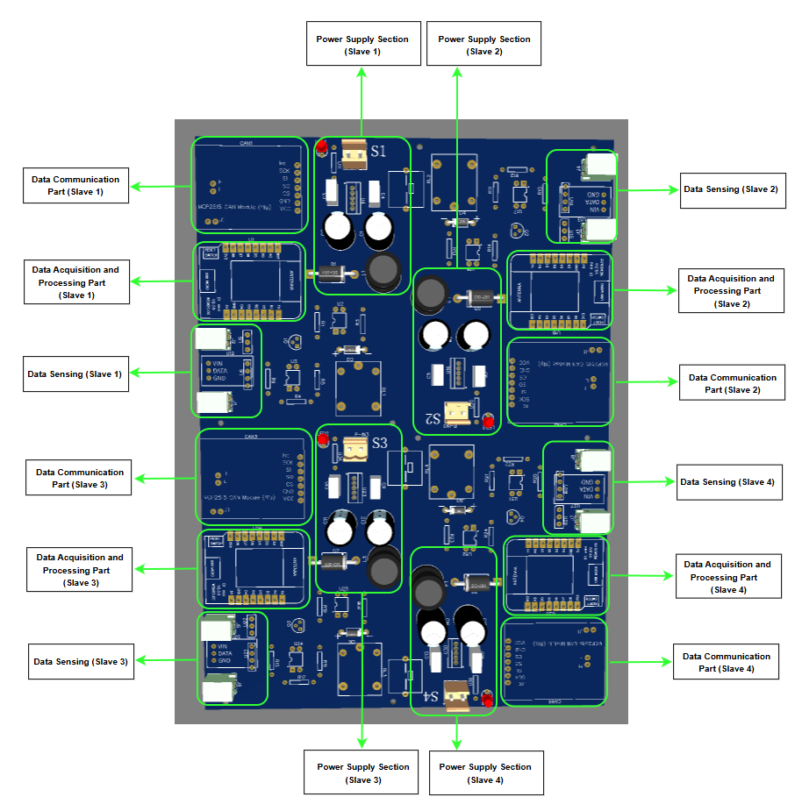

**GPIOs CONNECTIVITY ON MCU (Single Slave)**

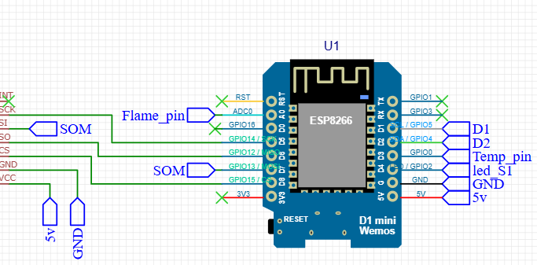

|  |  |
| --- | --- |
| **MCU** | **Sensor** |
| GPIO0 | Temperature Sensor (One Wire) |
| GPIO2 | Slot Indication LED (Data Pin) |
| GPIO1 | Cabinet Lamp |
| GPIO4 | Electromagnetic Lock Operating Pin |
| GPIO5 | Electromagnetic Lock Status Pin |
| A0 | Aerosol Fire Extinguisher Pin |
| GPIO12-GPIO15 | MCP CAN Module Connection Pins for Battery Specs |

Total: 10 GPIOs of the MCU are getting utilized.

**GPIOs CONNECTIVITY ON MCU (Master)**

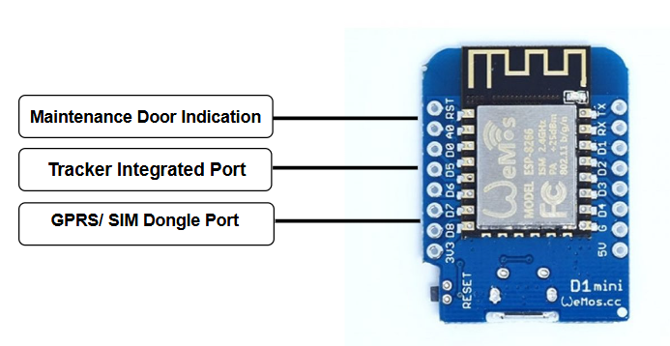

**OPERATING HAISHAN CS From Our CS PCB Board**

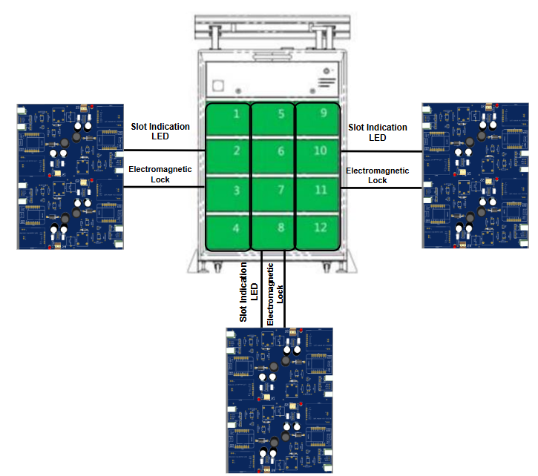

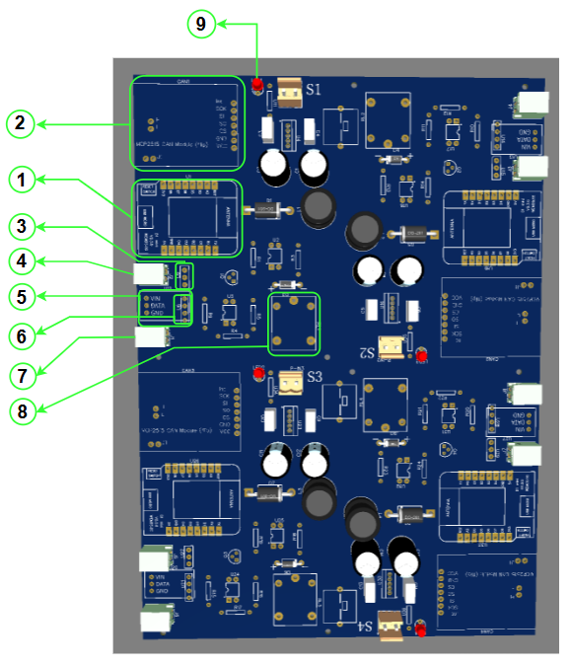

**ESP8266 (Component 1):** The ESP8266 is a versatile and cost-effective Wi-Fi module designed to enable seamless internet connectivity for a wide range of devices. It serves as a bridge between the physical world and the digital realm, facilitating data exchange and remote control.

**Working Principle:** At its core, the ESP8266 operates as a System on a Chip (SoC), integrating a 32-bit microcontroller with built-in Wi-Fi capabilities. This allows it to both process data locally and communicate wirelessly over Wi-Fi networks. The module supports the 802.11 b/g/n Wi-Fi standards, ensuring compatibility with a variety of network configurations.

**Functionality:** It performs the functionality of data acquisition, processing and transmission. It fetches data from the sensors (Temperature, flame and CAN) and operates the modules (LED and Lock) attached. After acquiring data from the sensors, it processes the received data, performs calculations, and make decisions based on it. For example, after receiving data from the CAN module, it performs data encoding and computation.

After fetching data from the sensors and modules, ESP8266 transmits the processed data to the “*master”* ESP8266 via “*ESP-NOW”*. It is a protocol developed by Espressif, which enables multiple devices to communicate with one another without using Wi-Fi. The protocol is similar to the low-power 2.4GHz wireless connectivity. The pairing between devices is needed prior to their communication. After the pairing is done, the connection is safe and peer-to-peer, with no handshake being required*.*

**MCP2515- (Component 2):** The MCP2515 is a high-speed CAN (Controller Area Network) transceiver that enables reliable and efficient communication between electronic control units (ECUs) in automotive and industrial applications. It offers a cost-effective and flexible solution for implementing CAN bus networks.

**Working Principle:** The MCP2515 operates on the CAN bus protocol, a robust and reliable communication protocol that allows multiple devices to communicate with each other without a central controller. It employs a carrier-sense multiple access with collision detection (CSMA/CD) mechanism to ensure reliable data transmission.

**Functionality:** When the system is powered on, the MCP2515 initiates communication with the BMS over the CAN bus. This high-speed communication protocol allows for efficient and reliable data exchange between the two devices.

The BMS, in turn, collects real-time data from various sensors within the battery pack. These sensors monitor crucial parameters such as:

* **Battery Voltage:** The overall voltage of the battery pack.
* **Battery Current:** The current flowing into or out of the battery.
* **State of Charge (SoC):** The percentage of remaining charge in the battery.
* **Temperature:** The temperature of individual cells within the battery pack.
* **Battery Capacity:** The total energy storage capacity of the battery.
* **Individual Cell Voltages:** The voltage of each individual cell within the battery pack.

Once the BMS collects this data, it transmits it to the MCP2515 via the CAN bus. The MCP2515 then receives and processes this information, making it available for further use by other components in the system, such as the ESP8266.

**DS18B20- (Component 3):** A versatile and waterproof temperature sensor that operates reliably in temperatures ranging from -55°C to +125°C.

**Working Principle:** It works on the principle of 1-Wire Interface which requires only one data line (and ground) for connection to the microcontroller, making it easy to integrate.

**Functionality:** Attached inside cabinet, it measures temperature of each cabinet.

**Solenoid Lock- (Component 4):** A solenoid is inside every cabinet used to open/close the cabinet door via dashboard.

**WS2812B- (Component 5):** A type of individually addressable RGB LED that can be controlled independently, allowing for precise control over colour and brightness. It has been used to show battery status inside the cabinet (battery fully charged, battery charging, fault indication).

**KY-026- (Component 6):** A small, inexpensive, and easy-to-use flame sensor module that can detect infrared (IR) light emitted by flames. It's particularly sensitive to wavelengths between 760nm and 1100nm, which are commonly emitted by flames.

**Solenoid Lock State Detection- (Component 7):** Used to detect current state of the solenoid lock.

**Relay- (Component 8):** Used to operate a lock by directing power to the lock's actuators after getting control signal from the MCU.

**LED- (Component 9):** Used to indicate which slave is operational on PCB.